Results
The present study was carried out between July 2011 to June 2012. This study included 500 eyes with different stages of diabetic retinopathy (DR).(197 males , 303 females). Their ages ranged from (20 - 80 yrs).Female patients are(172) 262 bilateral eyes and 41 unilateral eyes while male patients are(115) 162 bilateral eyes and 35 unilateral.

They were candidate for Fluorescein Angiography (FA). They were selected among the patients attending Sohag University hospital, ophthalmic out-patient clinic, and referred patients from internal medicine department and ophthalmic private clinics.
Student T- test was used to determine significant for numeric variable. Chi. Square was used to determine significance for categorical variable.
P > 0.05 no significant
P < 0.05 significant

Table (1): Demographic data of study group.
Item | Descriptive
- Age  Mean ± S.D  (min – max )  - Gender :  - Male  - Female | 55.98±9.81  (20 – 80 )  197(39.4%)  303(60.6%)

Table (1) shows demographic data in study group with mean age 55.98±9.81 years with (39.4%) of them male and (60.6%) female.

Chart (1): Sex Distribution in study group.
Table (2): Relation between stage of diabetic retinopathy & ischemia
Diabetic retinopathy | ischemia |  | P= value
Diabetic retinopathy | No “n=436” | Yes “n=64” | P= value
- very mild NPDR  - Mild NPDR  - Moderate NPDR  - Sever NPDR  - Mild –moderate PDR  - High risk PDR  - Advanced diabetic eye disease | 92(21.1%)  164(37.6%)  54(12.4%)  47(10.8%)  19(4.4%)  47(10.8%)  13(3.0%) | -  8(12.5%)  11(17.2%)  19(29.7%)  9(14.1%)  12(18.8%)  5(5.8%) | P=0.000***
Chart (2): Relation between stage of diabetic retinopathy & ischemia
Table (2) shows relation between stage of diabetic retinopathy & ischemia with (12.5%) of ischemic patients were mild NPDR, (17.2%) were moderate NPDR , (29.7%) were sever NPDR, (14.1%) were mild moderate PDR , (18.8%) high risk PDR and (5.8%) were advanced diabetic eye diseases with highly significance difference (P<0.000).
Table (3): Classification of patient according to hypoglycemic media.
Item | Descriptive
- Insulin  - Hypoglycemic drugs  - Insulin + Hypoglycemic  - Duration of DM “ys”  mean ± S.D  ( min – max ) | 269(53.8%)-169 patients  229(45.8%)-116 patients  2(0.4%)-2 patients  11.68±6.7  (1.0 – 35.0 )

Chart (3): Classification of patients according to hypoglycemic media.
Table (3) shows classification of patients according to hypoglycemic drug with (45.8%) of cases were treatment by insulin, (53.8%) by hypoglycemic drugs and (0.4%) using insulin + hypoglycemic with mean of duration of diabetes were 11.68 years.
Table (4): Relation between Gender & ischemia.
Item | ischemia |  | P- value
Item | No ”n=436” | Yes ”n=64” | P- value
- Female  - Male | 273(62.6%)  163(37.4%) | 30(46.9%)  34(53.1%) | P<0.04*

Chart (4): Relation between Gender & ischemia.
Table (4) shows relation between gender & ischemia with 64 cases from study group had ischemia with (46.9%) of them females and (53.1%) males with significance difference (P<0.05).

Table (5): Relation between laterality & ischemia.
Item | ischemia |  | P- value
Item | No “n=436” | Yes “n=64” | P- value
- OD + OS  - OD or OS | 226(51.8%)  210(48.20%) | 38((59.37%)  26(40.62%) | P=0.899 n.s

Chart (5): Relation between laterality & ischemia.
Table (5) shows relation between ischemia and laterality with (50%) of cases with ischemic were OD & OS and (59.37%) were OD or OS (40.62%) with no significant difference.

Table (6): Relation between diabetes & ischemia.
Item | ischemia |  | P- value
Item | No “n=436” | Yes “n=64” | P- value
Type of treatment DM  - Insulin  - Hypoglycemic drugs  - Insulin + OH  Duration of DM “ys”  Mean ±S.D | 226(51.83%)  208(88.13%)  2(0.5%)  11.29±6.69 | 43(67.2%)  21(32.9%)  -  14.28±6.35 | P <0.04*  P<0.001**
Chart (6): Relation between diabetes & ischemia
Table (6) shows relation between type of treatment of diabetes & diabetic macular ischemia with (67.2%) of ischemic patients treated by insulin and (32.9%) treated by hypoglycemic drugs with significant difference (P<0.05). As regard the duration of DM there were highly significant difference between ischemia and duration of diabetes (P<0.001) with longer duration among patients with diabetic macular ischemia.
Table (7): Relation between hypertension & ischemia.
Item | ischemia |  | P= value
Item | No “n=436” | Yes “n=64” | P= value
Hypertension  - no  - yes  Duration of HT  Mean ±S.D | 209(47.9%)  227(52.1%)  9.08±6.97 | 34(53.1%)  30(46.9%)  11.53±9.11 | P=0.260 n.s  P=0.086n.s
Chart (7): Relation between hypertension & ischemia.
Table (7) shows relation between hypertension & ischemia with (46.9%) of ischemic patients had hypertension with no significant difference (P>0.05). Also no significant difference regarding the duration of hypertension.
Table (8): Relation between cardiac diseases & ischemia.
Item | ischemia |  | P= value
Item | No “n=436” | Yes “n=64” | P= value
Cardiac diseases  - No  - yes | 371(85.1%)  63(14.44%) | 57(89.06%)  7(10.9%) | P=0.098 n.s

Fig (8): Relation between cardiac diseases & ischemia.
Table (8) shows relation between ischemic heart disease & diabetic macular ischemia with (10.9%) of ischemic patients were cardiac diseases vs. (14.44%) in non ischemic with no significance difference (P> 0.05).

Table (9): Relation between kidney diseases & ischemia.
Item | ischemia |  | P= value
Item | No “n=436” | Yes “n=64” | P= value
kidney diseases  - no  - yes | 419(96.1%)  17(5.89%) | 64(100%)  - | P=0.460 n.s

Fig (9): Relation between kidney diseases & ischemia.
Table (9) shows relation between kidney diseases & ischemia with no cases having kidney diseases. Vs. (5.89%) in non ischemic diseases with no significant difference (P>0.05).

Table (10): Relation between smoking & ischemia.
Item | ischemia |  | P- value
Item | No “n=436” | Yes “n=64” | P- value
Smoking  - no  - yes | 385(88.3%)  51(11.7%) | 57(89.1%)  7(10.9%) | P=0.529 n.s

Fig (10): Relation between smoking & ischemia.
Table (10) shows relation between smoking & ischemia with (10.9%) of cases diabetic macular ischemia were smoking vs. (11.7%) of non smokers with no significant difference (P>0.05).

Table (11): Relation between eye surgery & ischemia
Item | ischemia |  | P- value
Item | No “n=436” | yes “n=436” | P- value
Eye surgery  - no  - yes | 381(87.4%)  55(12.61%) | 43(67.2%)  21(32.8%) | P<0.000 ***

Fig (11): Relation between eye surgery & ischemia
Table (11) shows relation between eye surgery and ischemia with (32.8%) of ischemic patients have had eye surgery vs. (12.61%) of non ischemic with highly significant difference (P<0.000).

Table (12): Relation between eye laser & ischemia.
Item | ischemia |  | P- value
Item | No “n=436” | Yes “n=64” | P- value
Eye laser  - yes  - no | 60(13.76%)  376(86.23%) | 13(20.3%)  51(79.68%) | P<0.006 **

Fig (12): Relation between eye laser & ischemia.

Table (12) shows relation between previous laser treatment and ischemia with (79.68%) of patients with ischemia have had eye laser vs. (86.23%) in non ischemic with moderate significant difference (P<0.001).
Table (13): Relation between VA, IOP & ischemia
Diabetic retinopathy | ischemia |  | P= value
Diabetic retinopathy | No “n=436” | Yes “n=64” | P= value
- VA  - IOP | 0.173±0.159  17.18±0.94 | 0.041±0.05  17.36±0.62 | P<0.004**  P=0.163 n.s

Table (13) shows relation between VA, IOP and ischemia with mean value in ischemic cases were 0.041 vs. 0.173 with moderate significant difference (P<0.001). As regard IOP there were no significant difference (P>0.05).

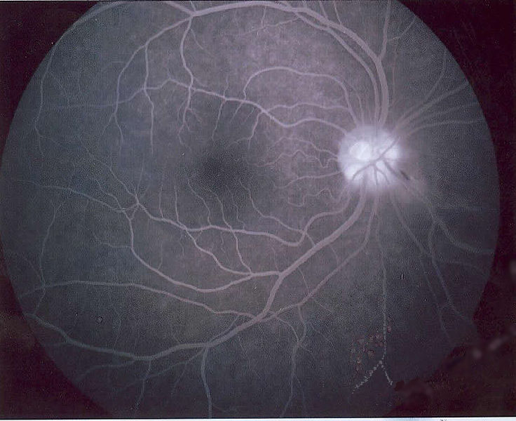

Fig 3.Normal FA

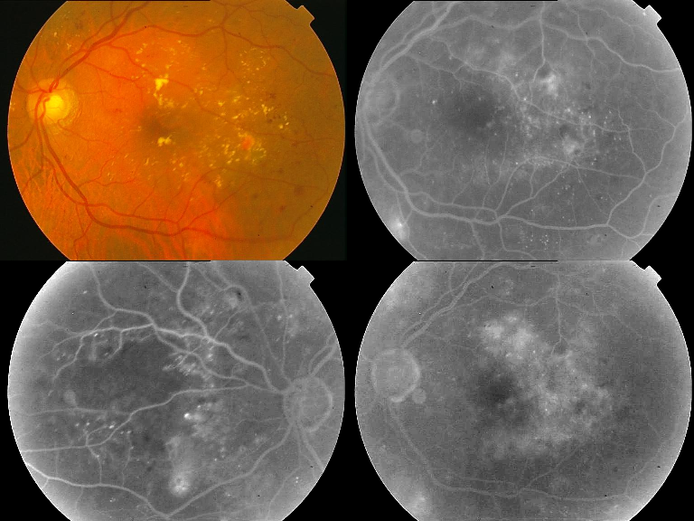

Fig 4. Mixed maculopathy

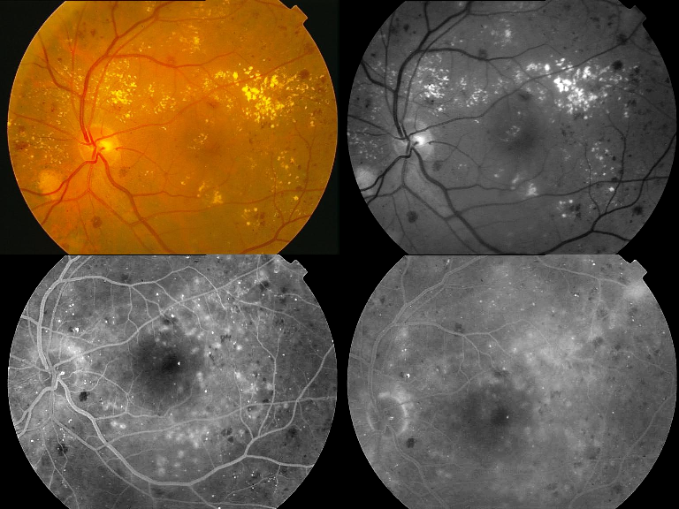

Fig 5.Mixed maculopathy

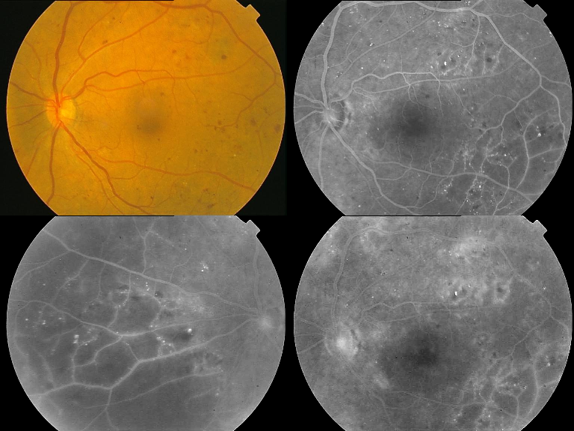

Fig 6. Moderate macular ischemia

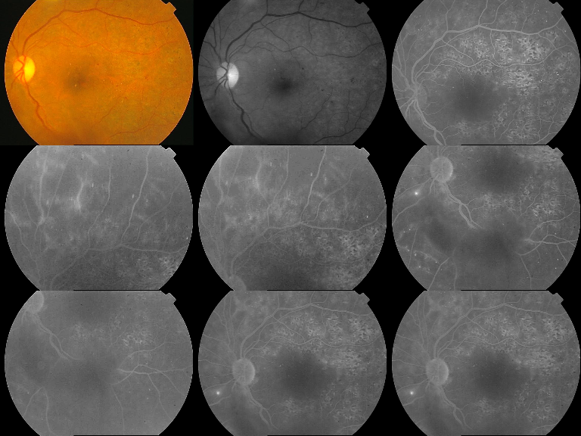

Fig 7. Sever macular ischemia

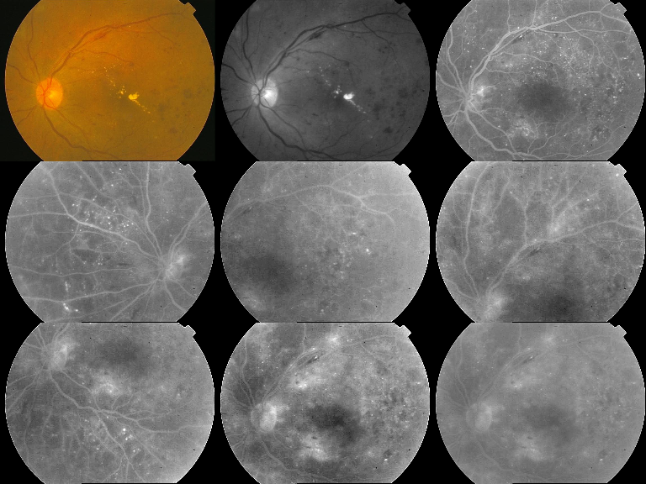

Fig 8.Moderate macular ischemia

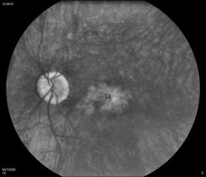
Fig 9. Macular oedema(CMO).

